**Create the World Database:**

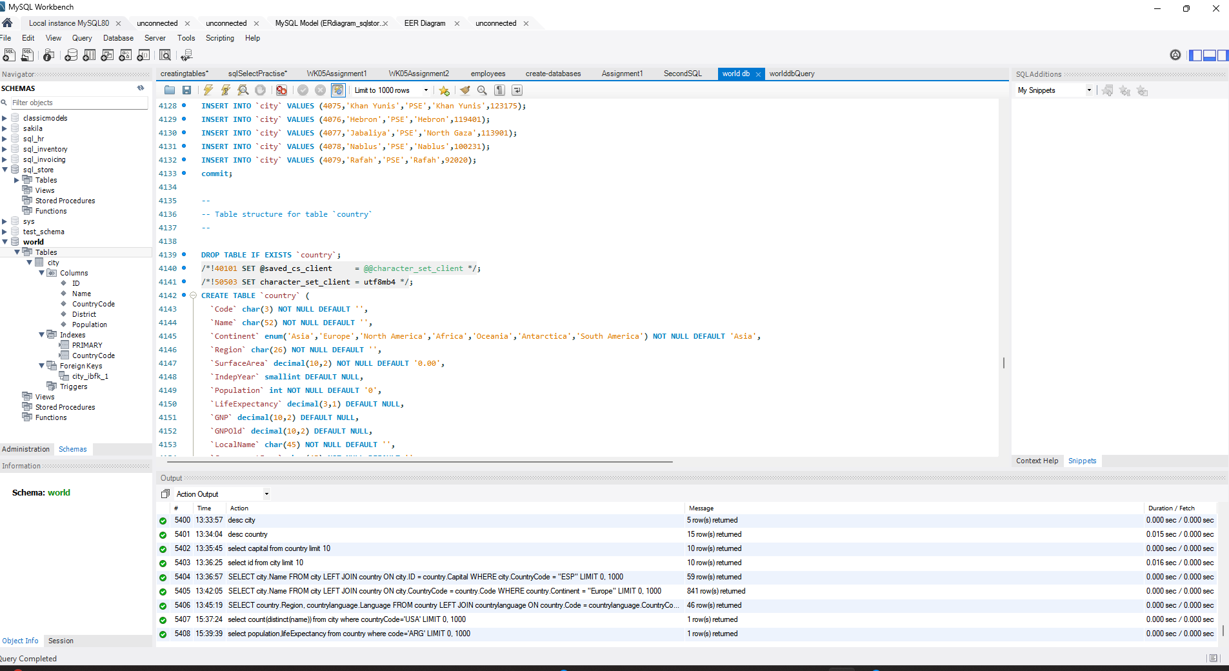

**Query1:**

Using count, get the number of cities in the USA

select count(distinct(name)) from city where countryCode='USA';

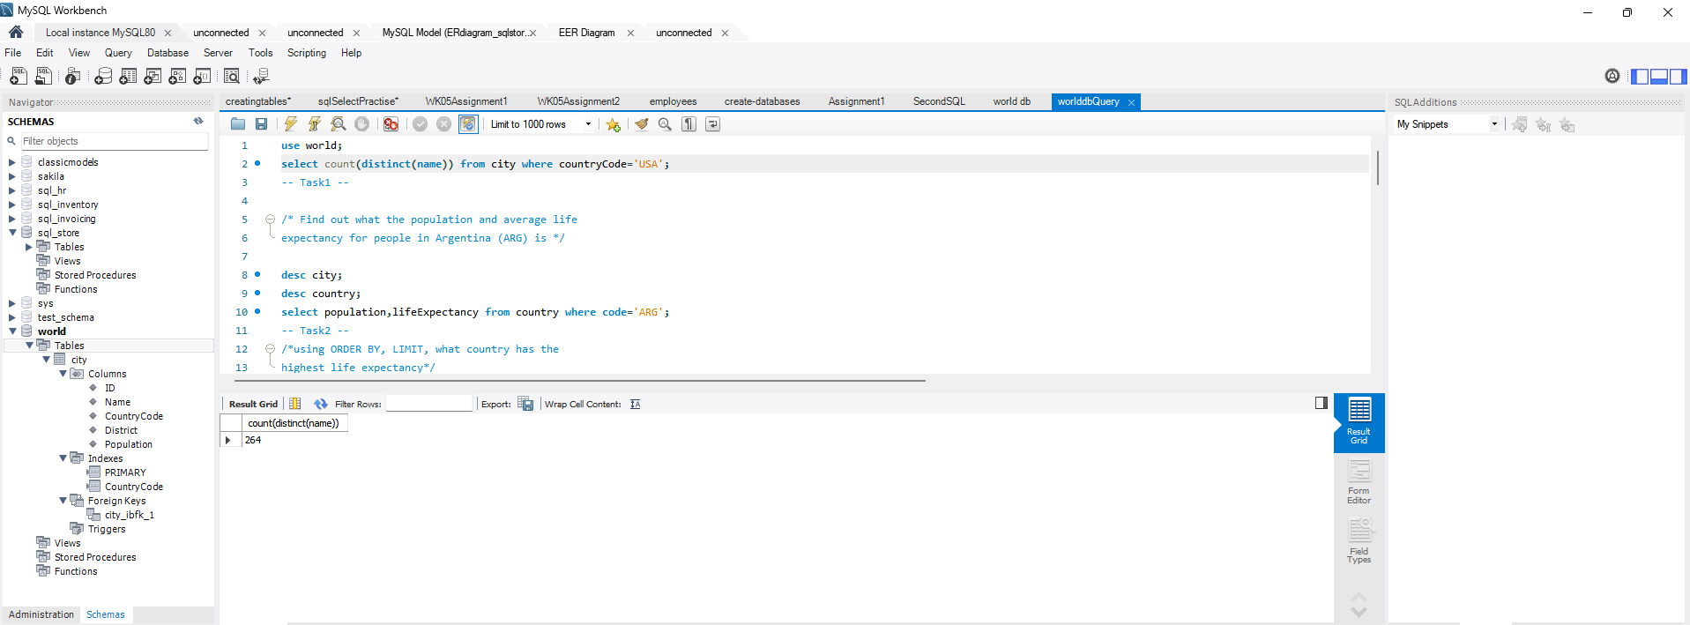

**Query2:**

Find out what the population and average life expectancy for people in Argentina (ARG) is

select population,lifeExpectancy from country where code='ARG';

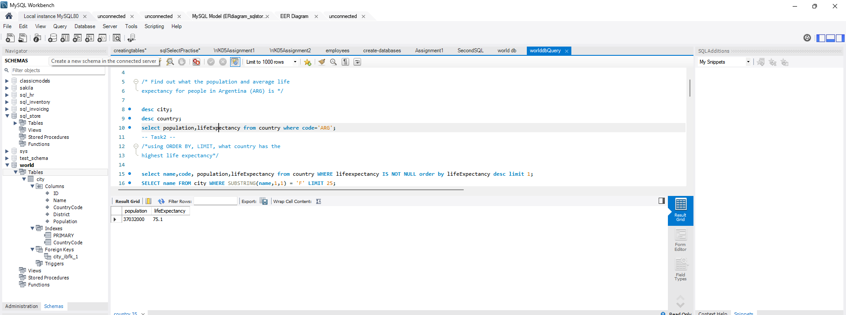

**Query3:**

/*using ORDER BY, LIMIT, what country has the

highest life expectancy*/

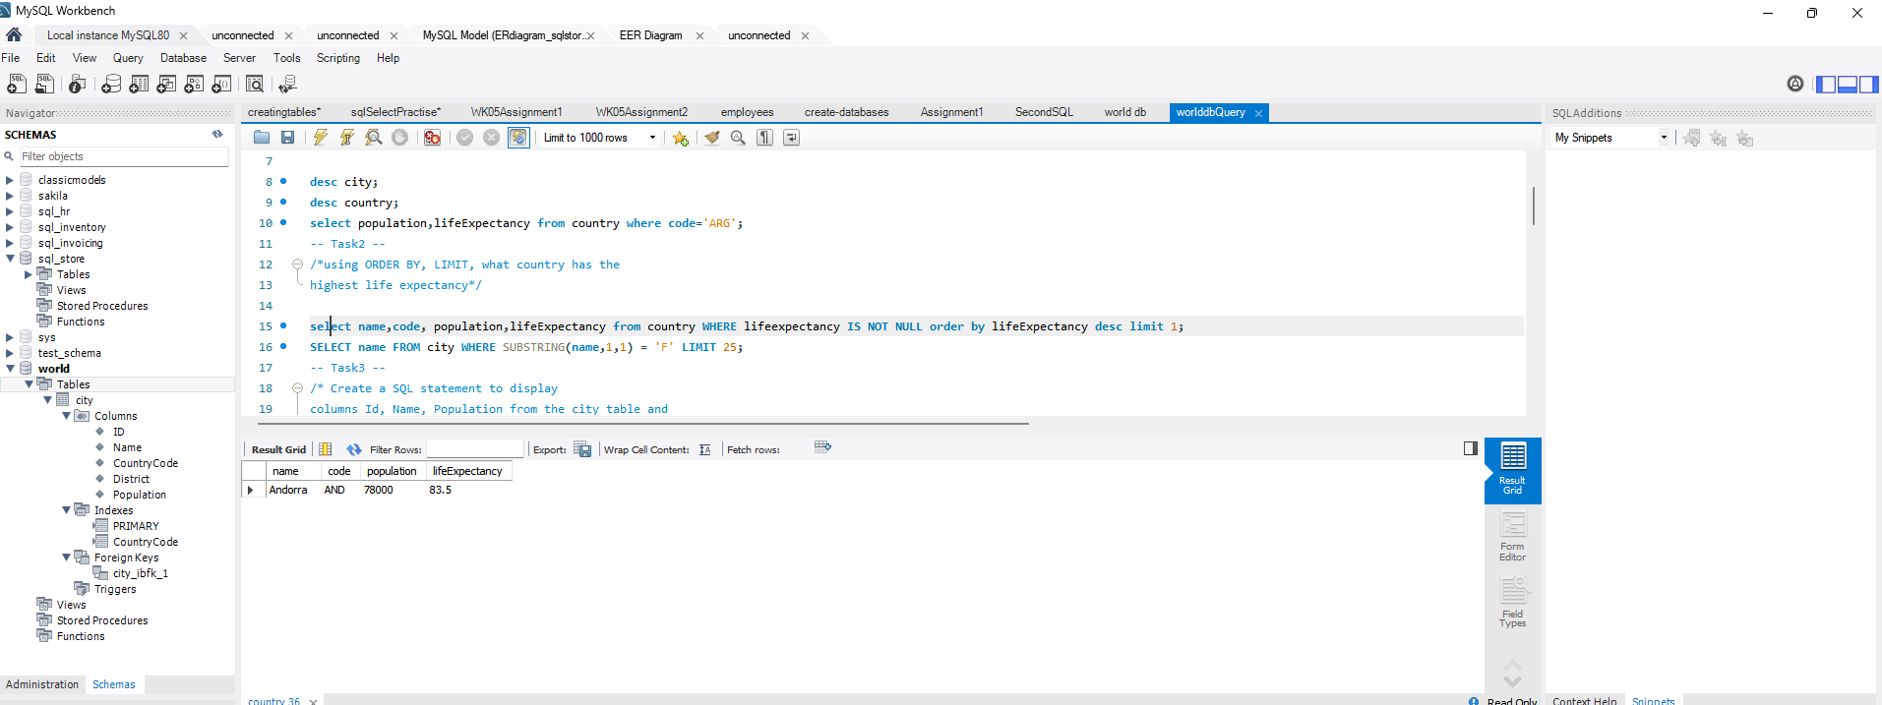

**Query4:**

Select 25 cities around the world that start with the letter 'F' in a single SQL query

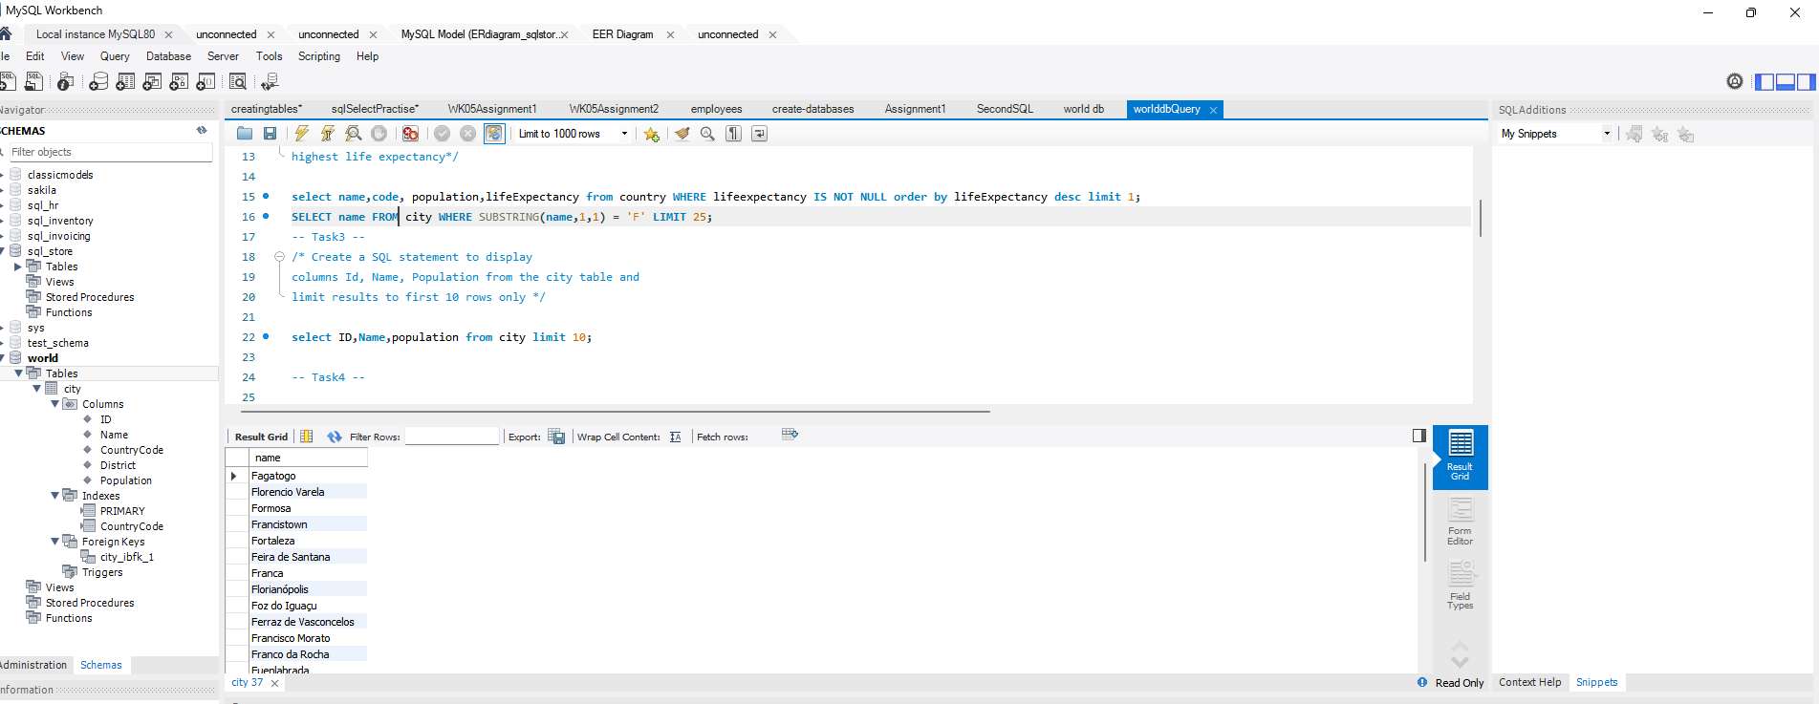

**Query5:**

Create a SQL statement to display columns Id, Name, Population from the city table and limit results to first 10 rows only.

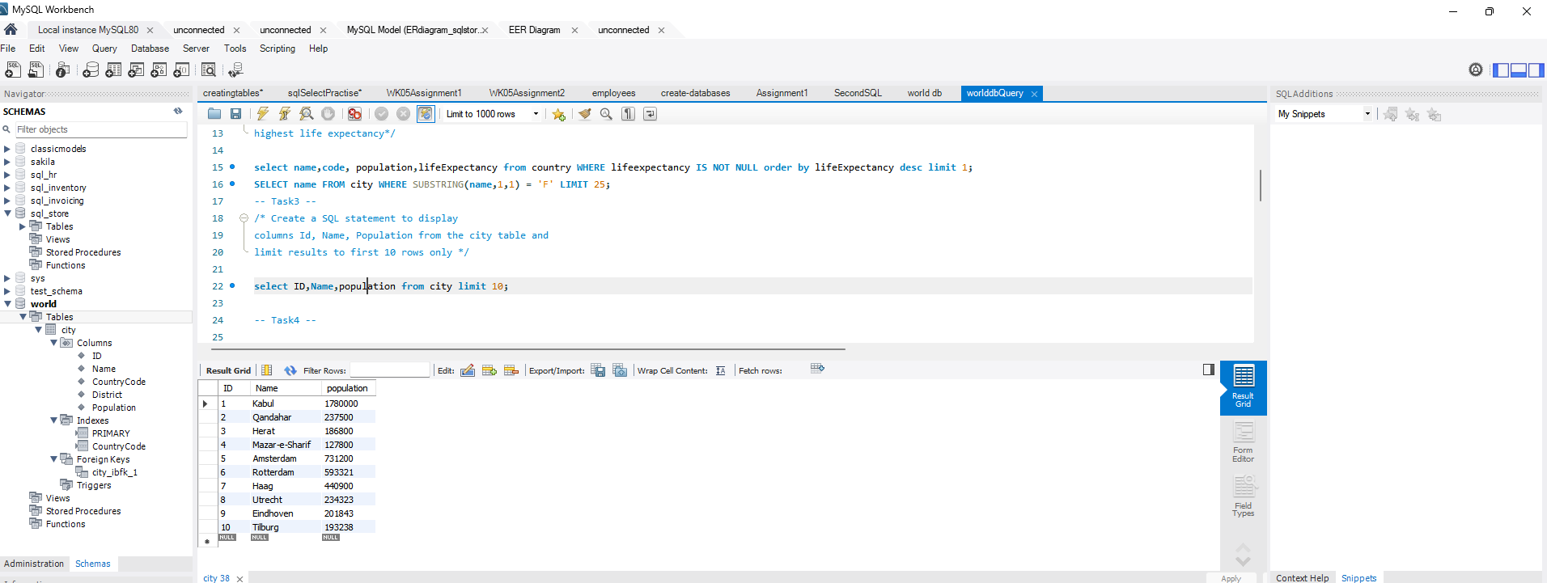

Query6:

•Create a SQL statement to find only those cities from city table whose population is larger than 2000000

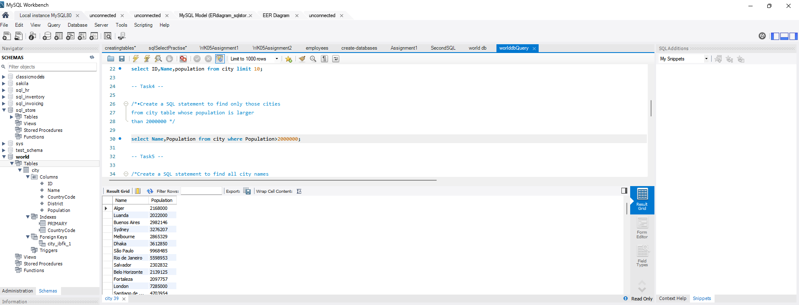

Query7:

Create a SQL statement to find all city names from city table whose name begins with “Be” prefix

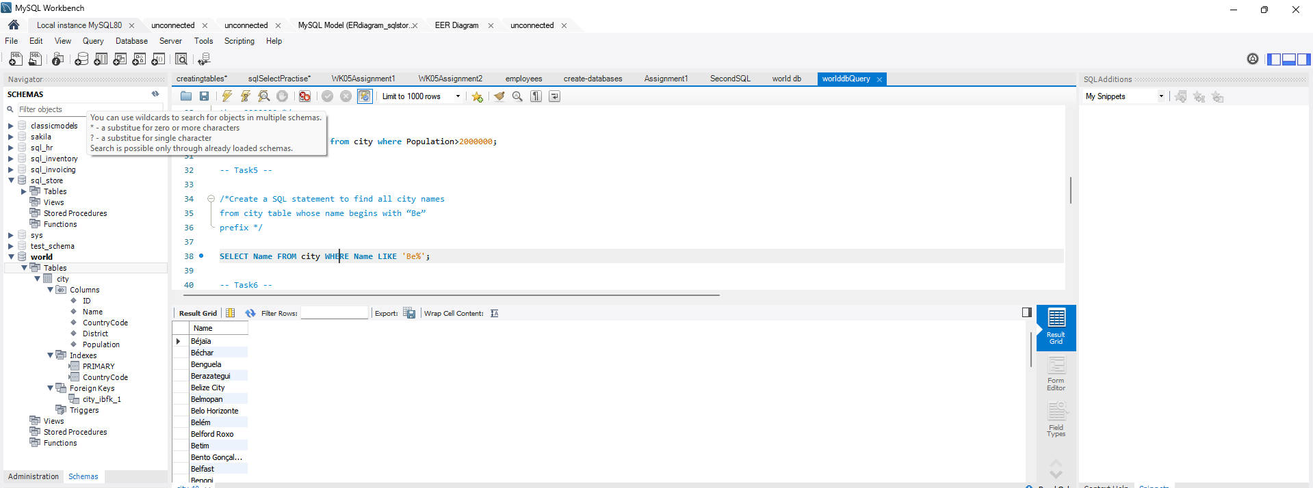

Query8:

•Create a SQL statement to find only those cities from city table whose population is between 500000-1000000

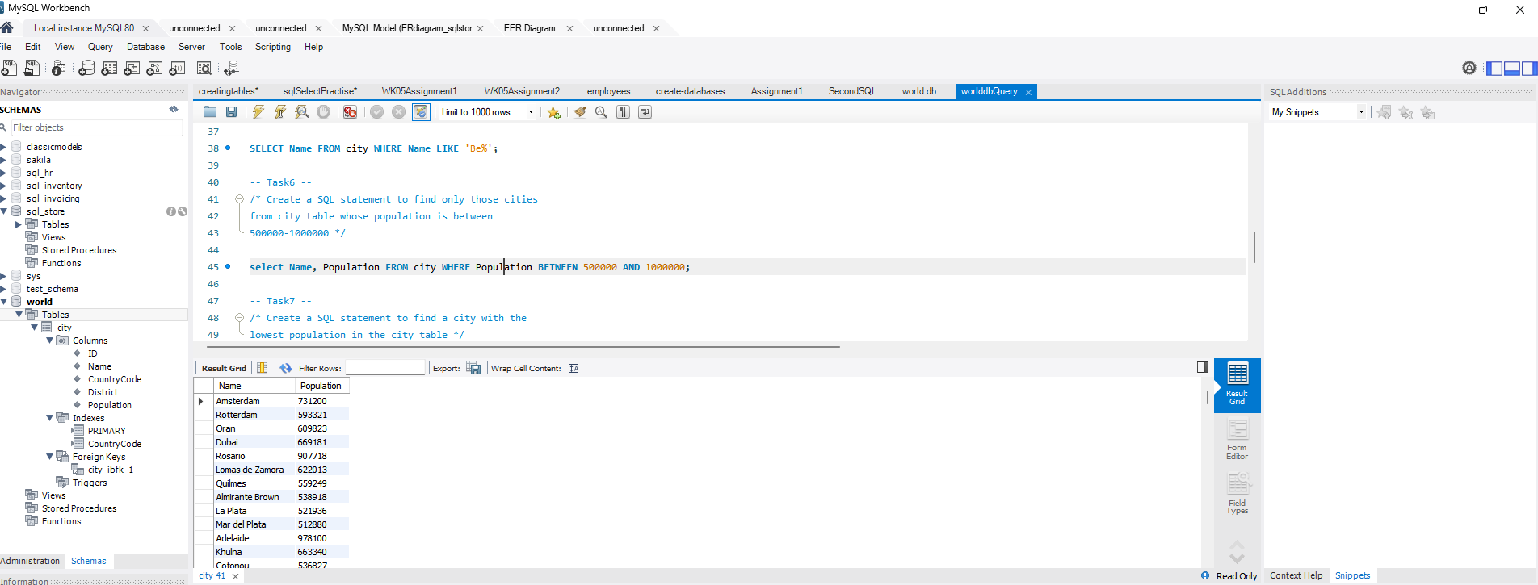

Query9:

•Create a SQL statement to find a city with the lowest population in the city table

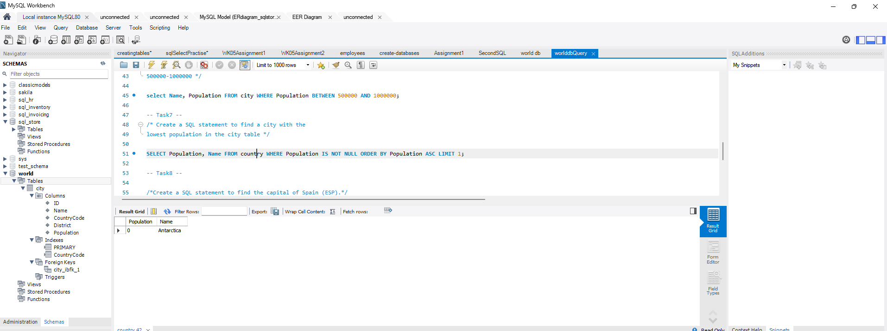

Query 10:

Create a SQL statement to find the capital of Spain (ESP).

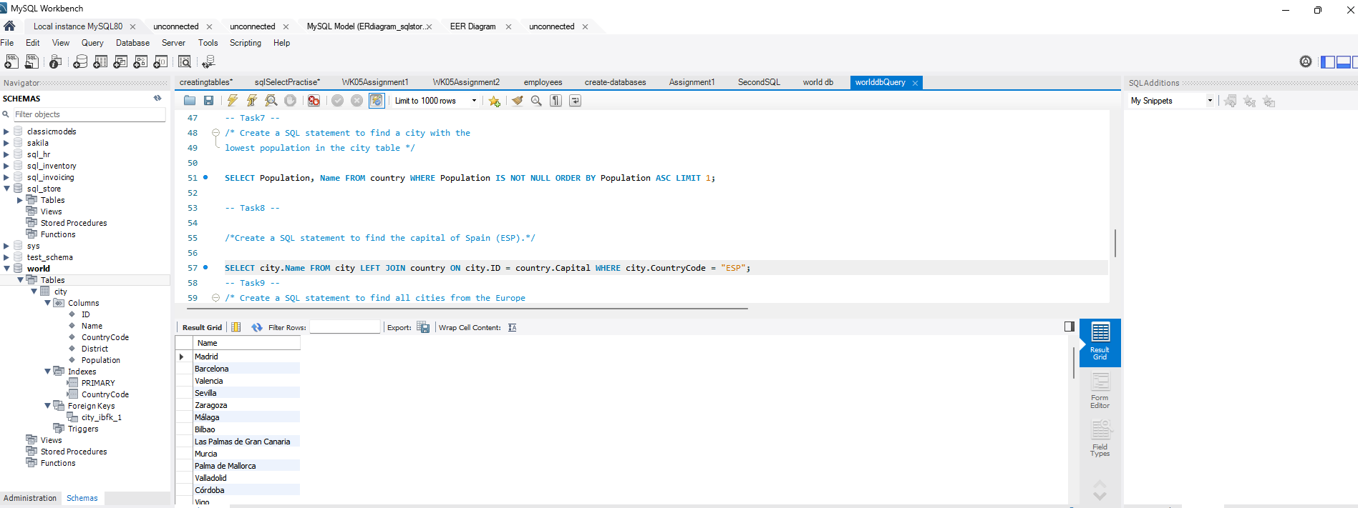

Query 11:

Create a SQL statement to list all the languages spoken in the Caribbean region.

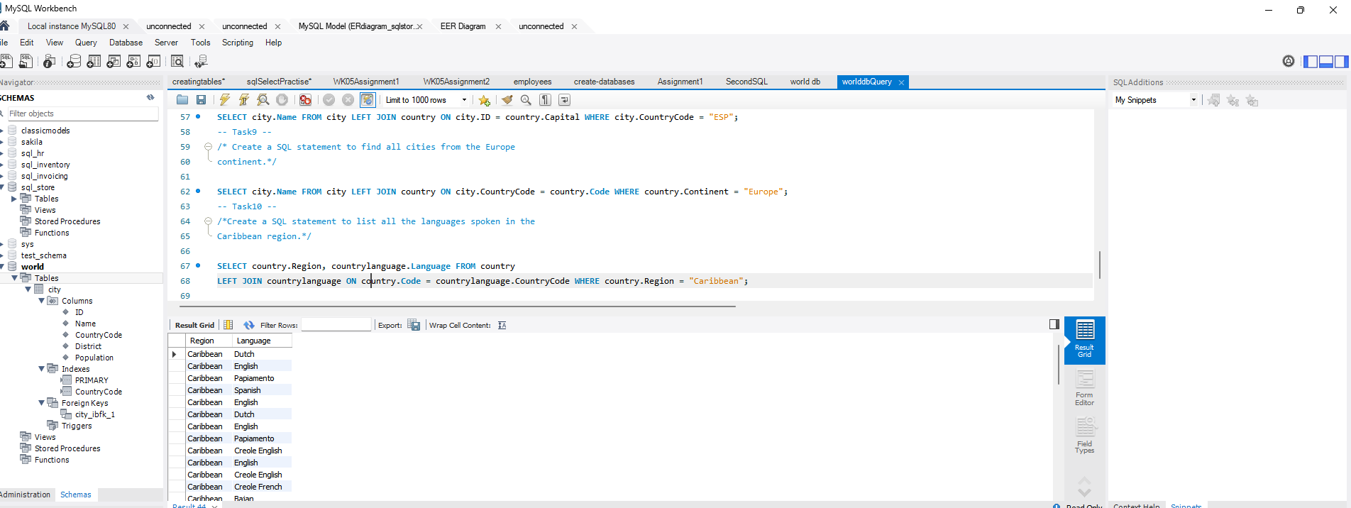

Query 12:

Create a SQL statement to list all the languages spoken in the Caribbean region.



Query 13:

/* Create a SQL statement to display columns Id, Name, Population from the city table and limit results to rows 31-40.*/

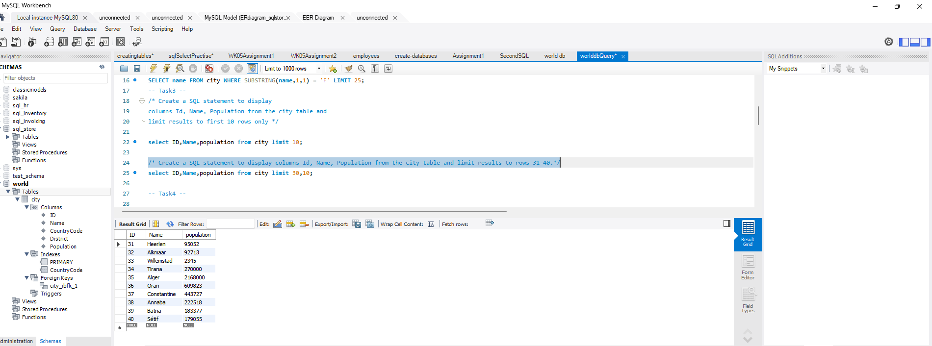

Query 14:

/* Create a SQL statement to display all cities from the city table sorted by Name in ascending order.*/

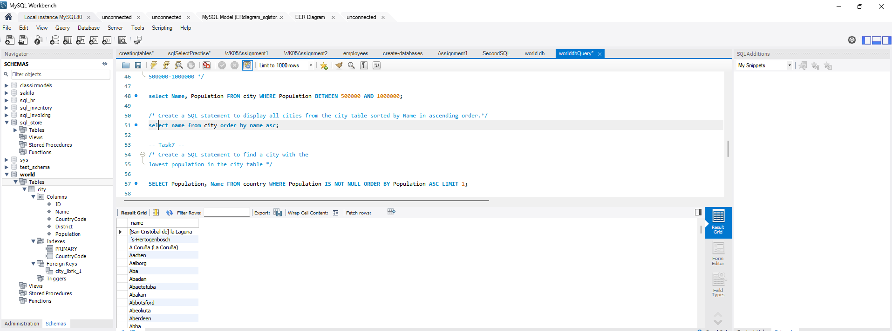

Query15:

/* Create a SQL statement to find a city with the

largest population in the city table */

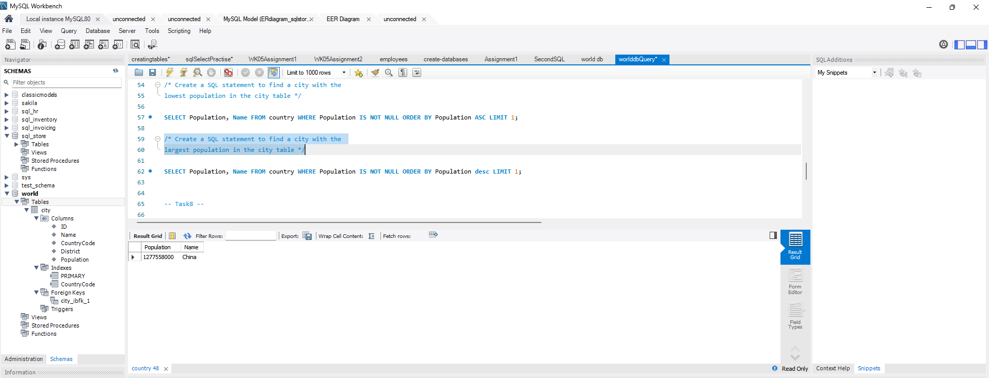

Query 16:

Create a SQL statement to find the most populated city in the city table.

World Database ER Diagram

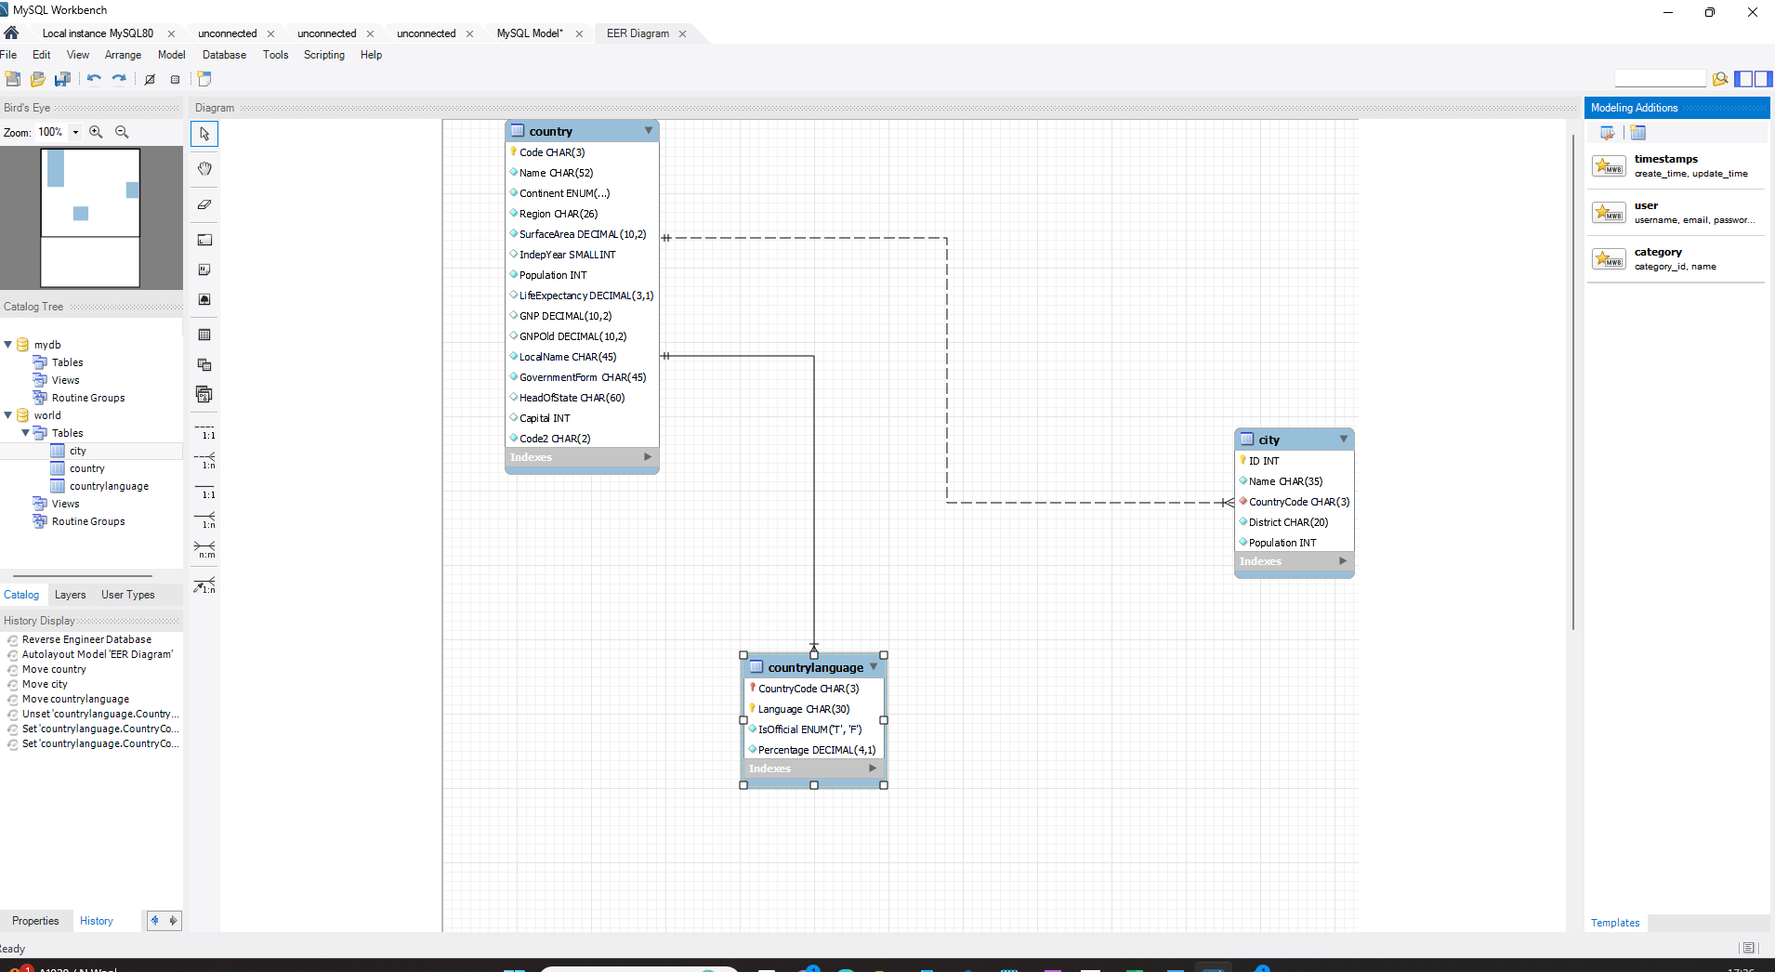

•Identify the primary key in country table. -Code

•Identify the primary key in city table. -ID

•Identify the primary key in countrylanguage table. -countrycode,language

•Identify the foreign key in city table. -CountryCode

•Identify the foreign key in countrylanguage table -CountryCode